**STATE UNIVERSITY OF ZANZIBAR (SUZA)**



NAME: FEISAL MASOUD ALI

REGISTRATION NO: BITAM/8/20/028/TZ

COURSE NAME: WEB APPLICATION

SUPERVISOR: MR MASOUD

**TITLE NAME OF THE PROJECT**

**RESTAURANT MANAGEMENT SYSTEM**

**DECLARATION**

First of all, I take this opportunity to thank ALLAH making me selected and be among the students of SUZA.

Secondly, I would like to thank my parents for motivating me to take this course (BITAM) and I am very happy that until now I have done very well for my first year and I hope the second year will be better than the first year inshaallah.

I would like also to express by special and sincere gratitude to our teacher MR MASOUD for accepting my project title. Also another thanks to our teacher Mr. Masoud for their cooperation, guidelines and instructions he gave me to complete my project as I learned and fulfill the main purpose of the Project to be able to apply what I have been taught in University (SUZA). Also he providing me good knowledge and skills with proper guidance in writing this report of the project.

And lastly, I would like to thank all those who in one way or another contributed to success of my Project.

INTRODUCTION

Restaurant Management System this is the system software which deal with different type of delicious food like sea food, vegetables, pizza etc. In this system our customer they order food and we make deliver everywhere in Zanzibar because we have many branches everywhere. Also you may booking in our restaurant if you want to come and eat in our restaurant and you may booking if you have celebration of anything either wedding, birthday party etc.

In Restaurant Management System it simplify customer and stuff because all order are record in the system and all payment are in the system.

RELATIONAL

OBJECTIVES

* GENERAL OBJECTIVES
* It help to simplify work by computerized system.
* It help to manage many customers at the same time.
* It simple and time consuming.
* It simplify customer by order and booking online and deliver.
* It simplify workers or stuff.
* CHALLENGE OF THE CURRENT EXISTING SYSTEM

In Africa we are in developing country hence we are not good in technology so some of our customers are not educated so it difficult for them to access our system. hence we lost our customers about that. So for us is a big challenge.

* SOLUTION TO THE CURRENT BUSINESS OPERATIONS

To overcome this we must give knowledge to our customers in order to give them the simple way to get their needs. Also we must tell them to use smart phone in order to interact with our system.

DELIVERABLES

The user of the system is our costumer and stuff, so the customer should get create account and to e member, so it help him/her to make order, booking and we supply what he/she order. User should make payment online by either mobile phone through tigopesa, ezypesa or bank.

FUNCTION REQUIREMENTS

* CUSTOMER
* Customer must be create his/her account.
* Customer must login after create account.
* Customer may order food.
* Customer my booking if there is any party.
* Customer must be payed after making order or booking.
* Customer must be log out after finish to order.
* STAFF
* Staff must be create account as a stuff not customer.
* Staff must be login after create account.
* Staff must check order of customer.
* Staff must give services to that order which is payed.
* Staff must log out after finish.
* SUPPLIER
* Supplier must create account as supplier.
* Supplier must login.
* Supplier must check the already order for delivery.
* Supplier must check the kitchen what is needed.
* Supplier must check the store to see what is needed or miss.
* Supplier must make confirmation for each deliver to customer.
* MANAGER
* Manager must create account as manager.
* Manager must check the customer order.
* Manager must give confirmation for each order.
* Manager must make calculation for all order at that day.

SECURITY REQUIREMENT

* User should create password.
* User should create unique username.
* User should inter his/her ID card number during create account.
* User should inter phone number.

DEVELOPMENT METHODS/METHODOLOGIES (agile)

This system we use agile methodology which our project we break it up in several phases. Also it involves collaboration with stakeholders and continue to improve at every stage. The agile involve three process which is planning, executing and evaluating.

* ADVANTAGES
* Customer satisfaction is rapid, continuous development and delivery of useful software.
* Customer, developer and product owner interact regularly to emphasize rather than process and tools.
* Product is developed fast and frequently delivered.
* A face to face conversation is the best form of communication.
* I continuous gave attention to technical excellence and good design.
* Daily and close cooperation between business people and developers.
* Regular adaptation to changing circumstances.
* Even late changes in requirements are welcomed.
* DISADVATAGES
* It’s not useful for small projects.
* There is lack of intensity on necessary designing and documentation.
* It require an expert project member to take decisions in the meeting.
* Agile is very expensive compare to other development methodology.
* The project can go out off track if the project manager is not clear about requirements and what outcome he/she wants.
* WHY WE DECIDED TO USE THIS METHODS
* Reduce technical debt.
* Easy and quickly adapt to change.
* Using agile for mobile application development and testing creates total alignment and transparency.
* Agile software development minimize risk.
* Higher quality product.
* Predictable delivery dates.
* Batter stakeholder engagement.
* User focusing testing.
* Greater customer satisfaction.
* Batter project control.

ARCHITECTURE OF THE SYSTEM (PROCESS FLOW)

CONCEPTUAL DESIGN OF THE SYSTEM

ENTITY RELATIONSHIP DIAGRAM (ERD)

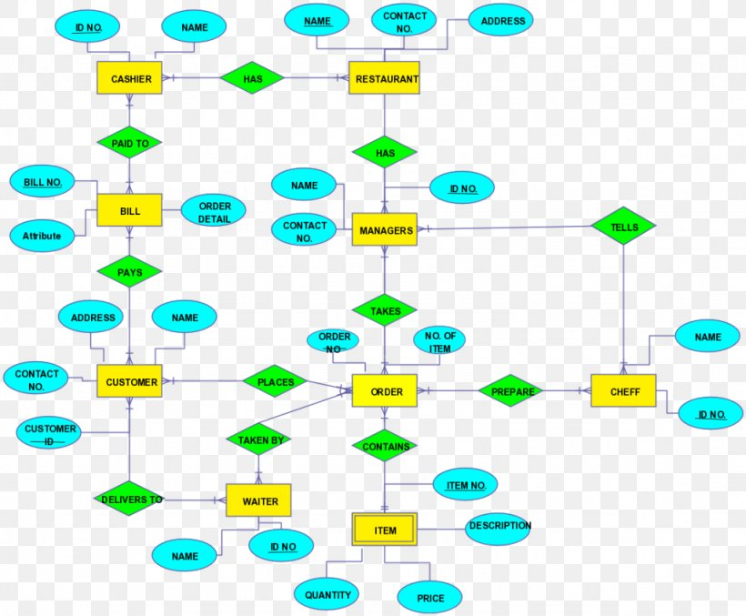

DATA FLOW DIAGRAM (DFD)

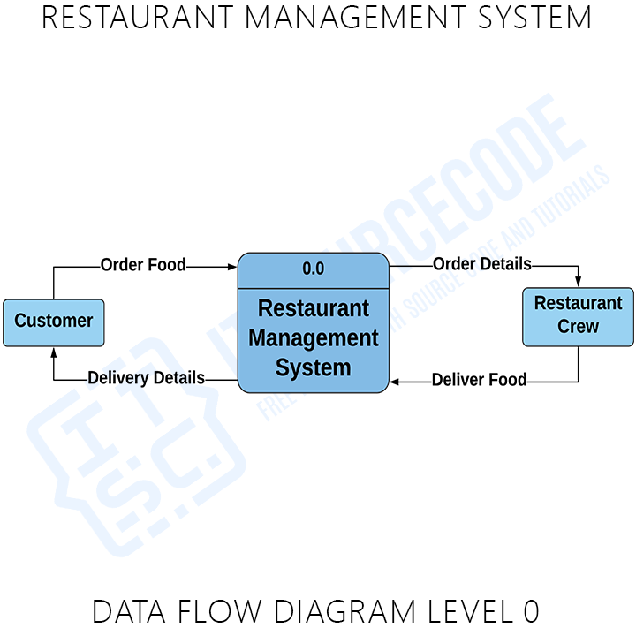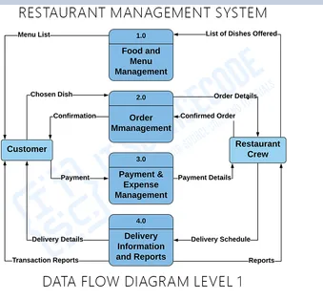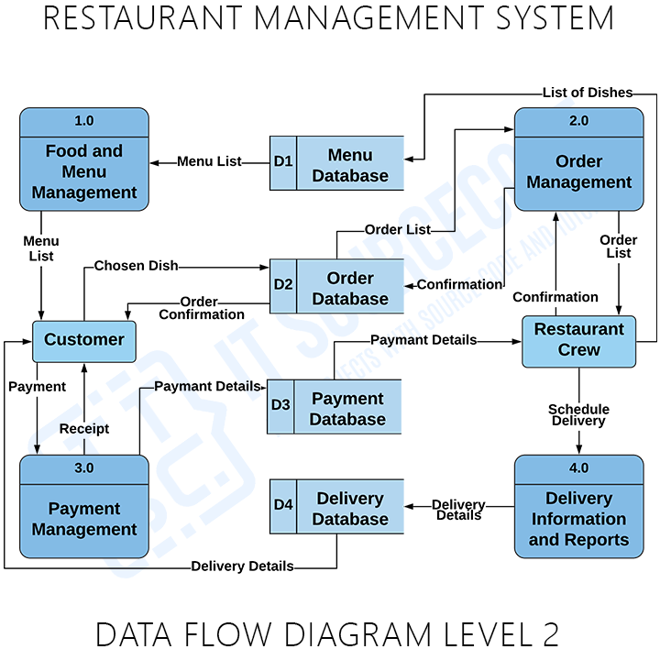

USER INTERFACE

DATABASE DESIGN

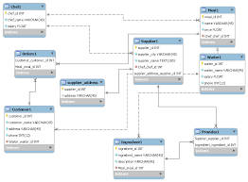

ACTIVITY FLOW OF THE SYSTEM

USE CASE TO EVERY FUNCTIONAL AND CLASS DIAGRAM REQUIREMENT

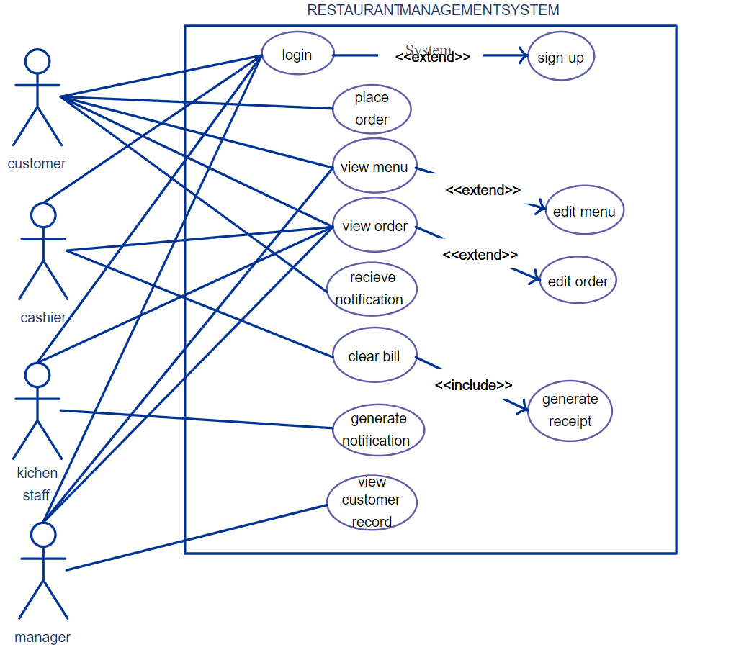

DEVELOPMENNT TECHNOLOGY (language)

* Html and Css
* JavaScript
* Spring boot